**SHIMONI DEMONSTRATION SCHOOL- KIRA**

**MID TERM TWO EXAMINATIONS, 2023**

**BABY CLASS READING**

**Name ____________________________________________________**

1. Colour a cat for sound **c**

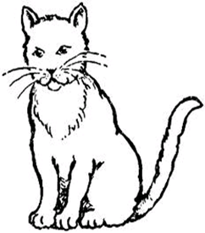

1. Copy and write.

|  |  |
| --- | --- |
|  | Cat |
|  |  |

1. Shade an apple for sound **a**

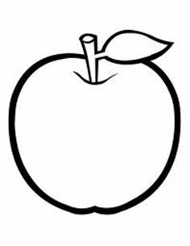

1. 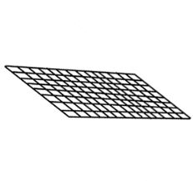Match sounds to pictures.

S

a 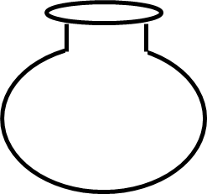

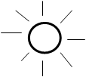

t

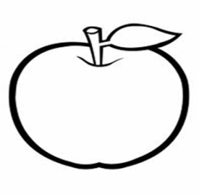

i

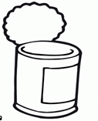

p

n 